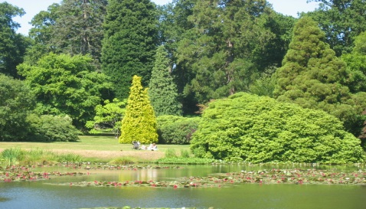

Our next visit is to

Loseley House & Gardens,

near Guildford,

which is often used for film sets and weddings,
On Wednesday 10th July leaving by coach at 9.30am from the Village Hall, and returning about 6.30.pm. The cost is £30 per person, which includes the coach, and a guided tour of the house and the garden.
Lunch can be pre-booked, which you will pay for separately, will be advised to you at a later date, or you can take a picnic. If you decide on the latter and it is wet, they do have a covered area with tables and chairs.
If you would like to join us, and would like to bring a friend, please let us know as soon as possible, and definitely by the next meeting, June 18th, when we will require full payment. Those of you who have already booked, paid £5 deposit, and if you have not yet paid the balance, we will also need that by the 18th June. We have 14 places available at the moment, and we will be offering them to other gardening clubs if necessary to try and fill the coach.
For more information go to their web-site at www.loseleypark.co.uk

